

217, Sheikh Rashid Building

P.O Box 56272, Dubai

United Arab Emirates

Tel: +971 4 2973236 / 04 2974007

Email: uae@verbat.com

PROJECT   
PROPOSAL

**Genset Management System**

|  |  |
| --- | --- |
| **Prepared for:**  **Middle East Container Repair Company LLC**  **Mr. Bhavesh Zala** P.O. Box-12345 Jebel Ali, Dubai, United Arab Emirates | **Submission Date:**  02 March 2017  **Proposal ID:** SW/12122016/1245/1 |

___________________________________________________________________________________________________________________________________________  
Conﬁdentiality Notice: This Proposal is conﬁdential and contains proprietary information and intellectual property of Verbanet Technologies LLC. Neither this proposal nor any of the information contained herein may be reproduced or disclosed under any circumstances without the express written permission of Verbanet.

© 2017 by Verbanet Technologies LLC. All rights reserved. Confidential.

___________________________________________________________________________________________________________________________________________

Project Contacts

|  |  |
| --- | --- |
| Client Information | |
| Project Name | Genset Management System |
| Client Name | Middle East Container Repair Co. (LLC) |
| Client Address | P.O. Box-12345, Jebel Ali, DUBAI, U.A.E |
| Phone Number | (+971 4) 8811685 Ext 228 |
| Contact Person | Mr. Bhavesh Zala |
| Contact Person Email |  |
| Contact Person Phone Number | (+971) 568280668 |
| Contact Person Fax Number | (+971 4) 8811691 |
| Verbat Information | |
| Contact Person | Ms. Joyce Daniel |
| Contact Person Phone Number | 04 2973236 |
| Contact Person E-Mail | Joyce.daniel@verbat.com |
| Address | PO Box 56272, Dubai |
| Physical Address | Flat 217, Sheik Rasheed Building, Hor Al Anz East, Dubai |
| Project Information | |
| Proposed Technology/Methodology | PHP / My SQL / Cordova (Hybrid Application) |
| Anticipate Start Date | NA |
| Proposal Valid For | 30 Calendar days from the submission of the proposal |

**Table of Content**

1 Executive Summary 5

1.1 Solution Objective 5

1.2 Advantages of Proposed Solution 7

1.3 Why Verbat 8

1.4 Key Differentiators 9

1.5 Underlying Support Services 10

2 Functional Specification 11

2.1 Step 1 11

2.2 Step 2 11

2.3 Step 3 12

2.4 Step 4 12

3 Solution Architecture 13

4 Application Workflow 14

5 Project Scope 16

6 Assumptions 18

7 Out of Scope 18

8 Technology Solution 19

8.1.1 MECRC Admin 19

8.1.2 Hybrid Mobile Application 19

8.1.3 Screen resolutions and devices 19

8.2 Technical Configuration 20

8.2.1 Technical Guidelines 20

8.2.2 Development Tools 20

8.2.3 Minimum Recommended Server Specification 21

8.2.4 Browser Compatibility for Web Admin 21

8.2.5 Hardware Interface 21

9 Delivery Management 22

9.1 Project Management 22

9.2 Roles and Responsibilities 22

9.3 Phase Delivery Activity summary 23

9.4 Project Implementation plan 23

9.5 Deliverables 23

9.6 Deployment Details 24

9.7 Release Planning 24

9.8 Risk and Contingency planning 24

10 Change Management 26

11 Project Effort & Timeline 27

11.1 Effort Estimate 27

12 Commercial overview 28

12.1 Hybrid Application Development Cost 29

12.2 Web Hosting Cost 29

13 Miscellaneous 30

13.1 Warranty 30

13.2 Acceptance Criteria 30

13.3 General Terms and Conditions 30

13.4 Assumptions and Dependencies 31

13.5 Source Code & Intellectual Property Rights 31

14 Our Clients 33

# Executive Summary

**Middle East Container Repair Company (MECRC) L.L.C**. (Here after referred to as the “Client”), is the leading company providing container repair services in the U.A.E., with depots inside the ports of Jebel Ali and Khalifa. The client would like Verbat to develop a **Hybrid Mobile App and Web Application** to automate their generator set rental process.

Hybrid Mobile App and Web Application Development is an area where Verbat has in-depth knowledge and expertise. Being the pioneers in Web based and Mobile based solutions across the major verticals, we are sure to help you enhance your customer engagement to drive differentiation. We bring proven methodologies and processes, global expertise in application development, and a legacy of best practices and ready-to-fit frameworks to expedite the development cycle and reduce the total cost of ownership.

Verbat is pleased to have received the request to submit the proposal and values it as a great opportunity to have a long term & mutually beneficial association with the client. Verbat has gone through the requirement and presents a technical and commercial proposal for the requested system.

## Solution Objective

The client has contacted Verbat Technologies to develop a Genset Management System that will mobilize and expedite their Genset Rental Process. The Admin dashboard shall be available on web via a tablet or desktop based browser. The Client dashboard shall be accessible via a hybrid mobile application.

**The main features of the application are listed below**

* **Admin (Web Application)**
* Login
* Admin Dashboard
* Manage Users, Customers & Gate Clerks
* Manage Genset, Genset Bookings
* Manage permissions
* Generate Dispatch Gate Out
* Generate Receive Gate In
* Generate DGSet Dispatch Slip & receipt
* Check status
* Various Reports
* **Customer (Hybrid Mobile App)**
* Login
* Dashboard & Search
* Add credit
* Book Genset
* Hire Genset
* Confirm Genset & Payment
* Generate QR Code & email
* Customer Inbox
* Generate customer receipt
* Inbox for messages and status updates
* **System Features**
* Authentication & authorization
* Basic Auditing & logging
* Payment gateway integration
* SMS & email integration
* Status updates
* Responsive website
* Hybrid version of the application

Verbat’s Solution architects have conducted a thorough research on the requirements and have come to the conclusion that our proposed solution, which is detailed further in this document, will meet the requirements put forth by the client. The proposed solution will be delivered in a single phase with both the Client and Admin Dashboards.

**Strong and Scalable platform:** The platform proposed will be strong and scalable enough to accommodate future enhancements such as scheduling, advanced auditing & logging, push notifications etc.

**Accelerated solution:** The framework would act as a solution accelerator. It would provide the basic building blocks which could be reused in future for building new components and features as part of enhancements

**High performance:** The light weight framework used consumes fewer system resources thereby making the application perform faster

**Security:** The application will be developed considering various aspects of security.

## Advantages of Proposed Solution

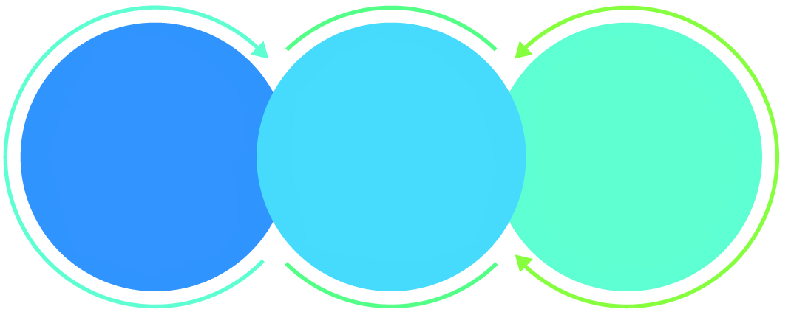

01

Agile development offering reliable, scalable and secure solution

02

Smooth transition and quicker completion of processes

03

User friendly interfaces enabling easy navigation between screens

## Why Verbat

Globally Accredited

Software Consultation Partner

Spearheaded by a   
team of Technology and   
Management Leaders



Over 16+ years of customer experience with Global   
Corporations

Service in Banking, Retail, Logistics, Construction & Contracting, Fashion, Manufacturing, Hospitality, Automotive, Healthcare and Government sectors

IT Strategy, Application Development and Maintenance, Testing Services, Information Management and Digital Marketing efforts



## Key Differentiators

Delivered digital transformation expertise to global customers for over a decade by following industry best practices to maximize ROI for client

Keen technology intelligence combined with aggressive market research to deliver solutions that achieve results with measurable value

Enable access to global consulting expertise with strong local market and business knowledge

Commercial Model that is customizable for your business needs

Reuse of code libraries for Rapid Application Development

1,000,000 plus man-hours of expertise in technology frameworks spanning Microsoft, Open Source, mobility platforms and other proprietary IT technology

Partners top technology vendors to bring in the latest and best services in integration, collaboration, and development

Commercial Model that is customizable for your business needs

Proven Methodologies & Processes

Investment in R & D

Strong Local Presence

Flexible commercial Models

Technology Associations

Code Repository

Software Development Experience

Offshore Development Centre

## Underlying Support Services

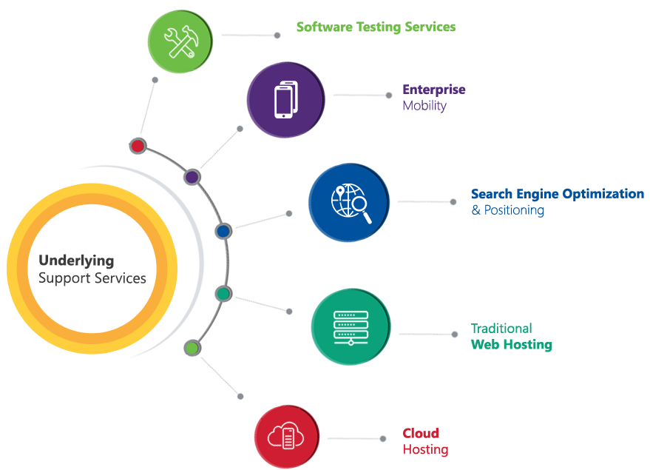

# Functional Specification

The application will be developed to simulate the workflow provided by MECRC. As such the application development will be broken down into **4 Steps** but completed in a **single phase**

## Step 1

MECRC will solicit clients to sell their services. If the clients accept the terms of the service they will have to pay a security deposit (paid offline) to utilize the services provided by MECRC.

As part of step 1 the following functionality will be developed

* Authentication and Authorization for Clients and MECRC users
* Create/register Customer by MECRC user
* Mark the customers from whom security deposit was received
* Client dashboard with indicative status of their orders and bookings
* MECRC dashboard with
  + List of registered users
  + Users with a security deposit payment
  + List of bookings and hiring’s of Genset
  + Reminders for MECRC users to approve bookings and hiring of Genset

## Step 2

Once the customers has paid their security deposit, they will be authorized to conduct business with MECRC. Depending upon the availability, customers can book or hire Gensets. Barring unusual circumstances MECRC approves the clients request and the client pays for the Genset using the payment gateway integrated into the application.

As part of step 2 the following functionality will be developed

* Search for Genset
* Request for Booking or Hiring of Genset
* MECRC approval for Genset request
* Client pays for Genset through payment gateway
* Payment success generates a **QRCode** for client and emails are send to client and MECRC dashboard.
* Release forms, Hiring slip forms and Generator dispatch forms will be created during this step

## Step 3

Step 3 is the gate-out process where the customer takes ownership of the Genset. The gate clerk verifies the customer by scanning his QR-code and verifying the information that they have on record in the application. The customer along with the gate clerk inspects the Genset following which the hiring slip, invoice are generated. Notification emails and SMS messages are generated in the process.

As part of step 3 the following functionality will be developed

* Login and Order Status dashboard for the gate-clerk with a view of all incoming Genset hiring requests
* A form to log the inspection results
* Send request to inspector if inspectors are not available
* Generate invoice and hiring slips
* Notification emails and SMS messages after the invoice and hiring forms are generated
* Status emails on the Genset hiring process

## Step 4

At the end of the hiring period the customer returns the Genset. The Genset is inspected for damages. If damages are found client is notified else the gate clerk issues the dispatch slip.

As part of step 4 the following functionality will be developed

* Gate Clerk fills out the Genset return form
* Gate clerk inspects the Genset and records the result of the inspection
* If there are issues with the inspection results, client is notified via email.
* Inspection results printed and handed to the customer
* Create a dispatch slip if there are no issues with the Genset
* Update status of the order and complete the order process by closing the order

# Solution Architecture

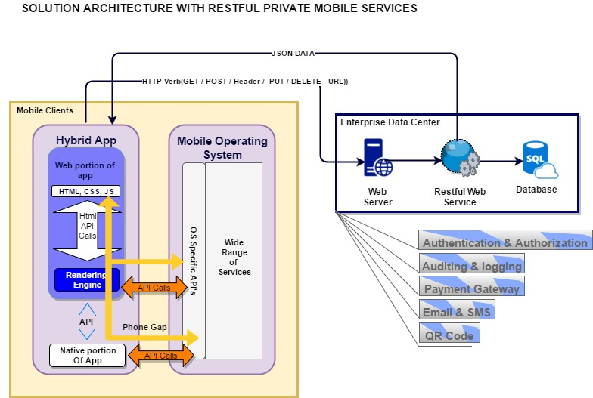

* Web application for MECRC users communicate with the webserver via a web browser
* The hybrid mobile app for the customer communicates via restful web services with the web server
* Common features baked into the application include
  + Authentication & Authorization
  + Auditing & Logging
  + Payment Gateway Integration
  + Email & SMS
  + QR Code Generation

# Application Workflow

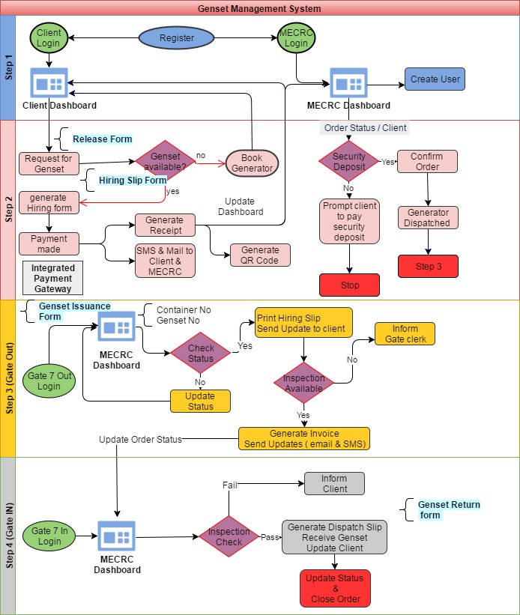

**Step 1**

MECRC will solicit clients to sell their services. If the clients accept the terms of the service they will have to pay a security deposit (paid offline) to utilize the services provided by MECRC. MERC shall create an account for the client so that the clients can login to the application and place orders or bookings

**Step 2**

Once the customers has paid their security deposit, they will be authorized to conduct business with MECRC. Depending upon availability, customers can book or hire Gensets. Barring unusual circumstances MECRC approves the clients request and the client pays for the Genset using the payment gateway integrated into the application.

**Step 3**

Step 3 is the gate-out process where the customer takes ownership of the Genset. The gate clerk verifies the customer by scanning his QR-code and verifying the information that they have on record in the application. The customer along with the gate clerk inspects the Genset following which the hiring slip, invoice are generated. Notification emails and SMS messages are generated in the process

**Step 4**

At the end of the hiring period the customer returns the Genset. The Genset is inspected for damages. If damages are found client is notified else the gate clerk issues the dispatch slip.

# Project Scope

|  |  |  |  |  |  |  |
| --- | --- | --- | --- | --- | --- | --- |
|  | | **Initiation** | | | | |
| 1 | | Requirements gathering and documentation (SRS) | | | | |
| 2 | | Functional Specification Document (FS) | | | | |
| 3 | | Finalizing and purchase of HTML Theme & Images | | | | |
| 4 | | Complete running prototype | | | | |
|  | | **Application Development** | | | | |
|  | | **Admin Area** | | | | |
|  | | | Manage User | |
|  | | | Manage Permission | |
|  | | | Manage Customer | |
|  | | | Manage Generator | |
|  | | | Dashboard | |
|  | | | Manage Bookings | |
|  | | | Manage Hiring | |
|  | | | Confirm | |
|  | | | Generate Receipt | |
|  | | | Send Alert SMS& Email | |
|  | | | Generator Dispatch Gate out | |
|  | | | Check Status | |
|  | | | Generate Receipt | |
|  | | | Send Alert Email | |
|  | | | Generator Receive Gate In | |
|  | | | DG Set Dispatch Slip | |
| 21 | | **Customer Area (Hybrid Application Development)** | | | | |
| 22 | | Login | |
| 23 | | Dashboard & Search | |
| 24 | | Add credit | |
| 25 | | Genset Booking | |
| 26 | | Genset Hiring | |
| 27 | | Confirm booking & Payment | |
| 28 | | Generate QR code, Print & email | |
| 29 | | Inbox | |
| 30 | | Online tracking | |
| 31 | | Payment gateway integration | |
| 32 | | SMS Gateway integration | |
| 33 | | Payment Receipt | |
| 34 | | Status updates (email, SMS, System update) | |
| 35 | | API development | |
| 36 | | Develop Hybrid app | |
| **52** | | **Application Testing** | | | | |
| 53 | | Testing and QA | | | | |
| 54 | | Go Live | | | | |

# Assumptions

The project solution and technology is created from the initial understanding of the requirement shared with Verbat through mails and meetings. The proposed solution is based on the following assumptions;

* API will be provided to update Genset location
* Payment gateway shall be purchased by client
* SMS Push service to be provided by client
* Application will be developed in English
* The client shall provide the branding guidelines
* Client shall provide licensed images and logos in specified size & format
* Color theme shall be provided by the client

# Out of Scope

With the ever evolving digital market, the requirement needs should be clear to both the parties involved, hence the importance of mentioning the out of scope details of the project. Following are considered to be out of scope while creating this proposal.

* Developer Account to Google Play store
* Purchase of themes if any
* Purchase of images, fonts
* Adding new features to the application other than mentioned in this proposal
* Any language other than English
* Manual data entry
* Database migration
* Physical deployment at client’s site
* Backup solution and Disaster recovery for web hosting
* Content writing
* QR Code Reader
* Annual Maintenance Contract

# Technology Solution

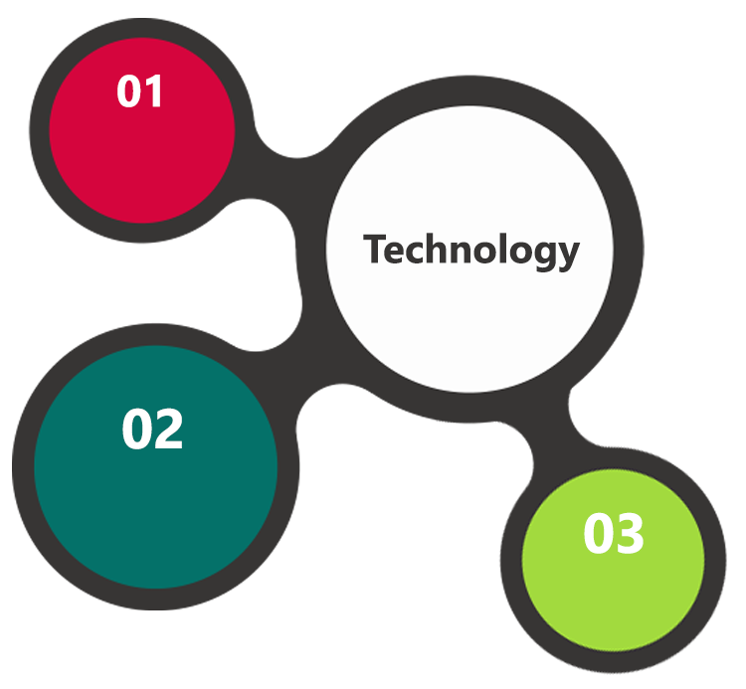

HTML 5  
JavaScript

PHP  
MySQL

Cordova

### Admin Area

* The MECRC admin application will be developed in PHP, CSS and Java script and will be deployed on to a web server with a MySQL database.

### Hybrid Mobile App

* Hybrid mobile app will be contained in a web view developed using PHP, CSS & Java script.
* Cordova shall be used to package the application so that it can be deployed into the Android store.

### Screen resolutions and devices

* Screen resolutions: 1024x600,1280x800,480x800,720x1280,1920x1080
* Testing Devices: Android Tablet Devices & Desktop

## Technical Configuration

### Technical Guidelines

The guidelines provide instructions and conditions that will be adhered to during the development of the mobile application

* The client will finalize the functional requirements and wireframe before the commencement of the project
* Verbat will be testing the app in the mentioned devices in mentioned in this document only, testing on devices other than the ones mentioned will have to be specified and provided by the client at the beginning of the development phase
* The client will have to provide the details of the testing devices they are using before the start of development phase
* Client should provide the relevant Developer's Account credentials before the development phase. In case Verbat needs to create the developer id additional charges will be incurred by the client
* The duration mentioned in the project time line is for development and testing and any delay or time taken by the review team to respond will not be Verbat’s responsibility
* Any clarification required from client needs to be addressed within 24 hrs.
* The apps will be developed / created within the guidelines of Android Play store and Verbat will strictly follow the guidelines. Verbat will inform the client if the any of the client requirements/ request deviates from it.
* Customization of the features of the app will be susceptible to the limitation imposed by the respective platform/ store
* Once development commences the test device/screen sizes will not be susceptible to change, any change requested by the client will have to go through change management
* OS version support will be limited to the ones mentioned in the technical specifications, further support will have to go through change management

### Development Tools

* Eclipse PHP editor, Draw.IO
* My SQL Management Studio & Photoshop

### Minimum Recommended Server Specification

We recommend to have a VPS Web server and should feature a combination of the following hardware/software

* Operating System: CentOS
* HDD Quota: 240 GB
* Processor: Intel Xeon Quad Core, 3. 3GHz (8 threads)
* Memory: RAM 8 GB
* Database Server Software: My SQL
* Web Server: Apache
* Language: PHP

### Browser Compatibility for Web Admin

* Chrome 56.0
* Firefox 51.0
* Internet Explorer 11

### Hardware Interface

The application is web based, it’s not dependent on any designated hardware, and it does not have any direct hardware interfaces. But we recommend the below specification for best output.

* Computer with Windows 8 or 10 OS
* Compatible Browsers as specified in this document

# Delivery Management

## Project Management

The Verbat development center strictly follows industry standards on quality. The project management is process governed by the Verbat Quality Management system and is put to verification through internal audit programs that happen from time to time.

Verbat will dedicate a project manager for the proposed implementation. Verbat proposes Client to identify one project manager who will be driving activities to be undertaken by Client to be the single point of contact for Verbat.

## Roles and Responsibilities

Verbat will assign a dedicated Project Manager/Project Lead to lead the project, who will be the first point contact for Client. He/she will be responsible for planning and managing the various activities within the project. He/she will work closely with Client Project Manager, to give periodic status updates and ensure high level of visibility and comfort on the progress of the project.

The Project Manager/Project Lead will lead the co-ordination between Verbat and Client, thus enabling smooth transitioning of Client requirements to the Verbat’s offshore delivery team, and provide visibility as well as comfort on the progress of the services to Client.

He/she will have periodic meetings with Verbat’s Senior Management, thus ensuring Verbat’s Management commitment and focus on Client initiatives.

## Phase Delivery Activity summary

|  |  |
| --- | --- |
| Activities | Description |
| Detailed requirement Analysis | Verbat team to conduct detailed study of requirement for the phase. If clarification is required, team will reach out to Client for more information and/or time for discussions. |
| Software Requirement Specification document (SRS) | Once the requirement analysis is completed, Verbat team will submit the SRS document for approval |
| UI/UX Design, Prototyping | Based on the SRS, Verbat UX/UI team will work on the UI/UX of the screens and submit a prototype for approval |
| Functional Specification Document (FS) | Once the Prototype. UI/UX is approved, Verbat shall submit an FS document for approval. |
| Development | Actual system development starts based on the FS. This involves detailed design and software development of Web Admin, API & iOS and Android mobile app. |
| Testing | Test Planning, test plan creations, internal, integration testing and user acceptance testing. |
| Deployment | Deploying the latest built in the Verbat Test Server. |

## Project Implementation plan

Verbat will be providing the solution in a step wise approach which ensures minimum viable solution for quick wins with core focus on the long term business objective and outcome.

## Deliverables

* Software Requirement Specification Document (SRS)
* Functional Specification Document (FS)
* Prototype of Admin Web module and Customer Hybrid App (Screen Shots)
* Fully Developed & Tested Hybrid App & Web Application
* Test Cases
* User Manual (English)

## Deployment Details

* Client shall provide Developer Account in Google Play store
* Client shall provide the server FTP, Root Access of the server for Application deployment

*Client can opt for hosting the web application at Verbat’s Server. Hosting the application at Verbat’s server will call in for additional charges*

* If deployment is at the client’s server, responsibility of deploying the delivered built or any other interim releases onto the production environment after conducting the necessary acceptance testing will lie with the client, unless and until Verbat’s support is contracted for deployment.

*Note: Hosting the application at Verbat’s server will call in for additional charges.*

## Release Planning

* Client will be informed about the release date and time through email.
* Client performs the UAT

## Risk and Contingency planning

Verbat has identified various risk factors associated with this assignment and understands the impact of these risk factors on the project schedules. The objective of this section is to highlight for both Verbat and client, the risk factors, to analyse the impact of the risks on project execution, and to propose strategies to control and reduce the impact of the risk factors.

These various risks, which could arise during the project, are tabulated below along with mitigation implementation.

| Type of risk | Impact | Risk Mitigation | Risk Handling |
| --- | --- | --- | --- |
| Scope Creep | H | Functions and features will be detailed in system requirement documents and will go through client approval. Once this document is approved, any change to requirement will go through change management review for possible impact assessment. | Proper change management procedure will be implemented. |
| Delay in customer feedback | H | The plan is prepared with enough lead-time for customer reviews and approvals.  The customer is indicated with the dates when the document is expected after review and approval. | The request for feedback will be escalated if not attended at the right time so that the schedules are not affected. Deemed acceptance criterion is set up front and will be followed. |
| Non-availability of necessary software’s, frameworks, database instances and infrastructure at client’s hosting environment(If hosting support is provided by Verbat) | M | Client will be informed in advance on these requirements. | Possible impact to schedule. |
| Manpower attrition | L | All efforts would be made to ensure process dependence rather than being person dependent. As a risk mitigation plan Verbat will train backups. | A new person will be identified as early as possible, provided the required project-specific training and mentored by the senior members of the team to minimise impact of attrition on the project. |

*H-High, M-Medium, L-Low, NA-Not Applicable*

# Change Management

Any addition which comes out of the project scope, upon and after the launch of the tool will be considered as change management. Verbat recommends the following change management procedure for the same.

* Any change which comes out of the project scope, which was discussed, documented, and mutually approved by both the parties in the requirement stage, will be carried out only through raising a change request.
* Change request will be studied and an impact analysis on the existing work flow will be performed.
* On finalizing the impact, effort estimation for the change will be calculated and raised as additional requirement.
* Verbat will initiate the change request only after getting a formal approval from the client for the additional changes raised.
* Any change from the scope will be charged at **AED 1200 per man day effort** and approval from the clients will be availed before commencing on any change management.

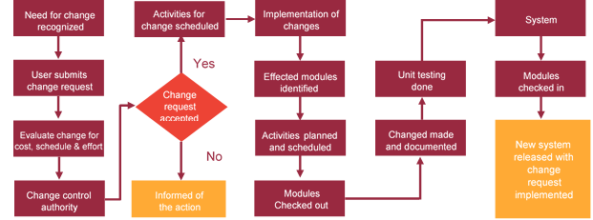

# Project Effort & Timeline

## Effort Estimate

The effort estimated for delivering the application as specified in this document will be as below:

|  |  |  |
| --- | --- | --- |
| **Activity** | **Effort (Man Days)** | |
| Initiation & Requirement Analysis | | 10 |
| Application Development | | 23 |
| Testing of the application | | 07 |
| Go Live | | 01 |
| **Total Man Days** | | **41** |

## Delivery TimeLine

|  |  |  |
| --- | --- | --- |
| **Activity** |  | **Delivery Days** |
| Application Development (Web + Hybrid App) |  | 30 |

# Commercial overview

|  |  |  |
| --- | --- | --- |
| **Description** | | **Cost (USD)** |
| Development of the Genset Management System | USD XXX,XX.00 | |
| Web Hosting of the Hybrid Application (Yearly)  **Hosting Specification**   * 4 Core CPU * 8 GB RAM * 240 GB HDD * 3 TB Bandwidth * 2 IPs * Full root access (64-bit) * Optional cPanel with WHM control panel * Apache web server * Supports: MySQL, PHP | USD 4,440.00 | |
| **Total** | | **$ X,XXXX.XX** |

# Miscellaneous

## Warranty

Verbat shall provide a bug ﬁx warranty at no additional cost for 30 days from the date of acceptance of the project, for correction of any errors in the developed application that may be attributed to Verbat.

However, this does not cover modifications by Client, or use of the application on an environment other than the proposed environment, or other circumstances outside Verbat’s reasonable control. In such a case Verbat reserves the right to charge for its services.

All error corrections will be executed at Verbat India office. In the event of any need for on-site work, all expenses incurred for such trips will be payable to Verbat by Client.

## Acceptance Criteria

* UAT sign off should happen within 14 Days from the release of each module/ Phase and the acceptance confirmation needs to be mailed to Verbat failing which Verbat will consider the project as approved by the client.
* Any comments or reason for rejection need to be documented and the same needs to be sent as an email from the official mail id of client to Verbat.

## General Terms and Conditions

* Offer Valid for 30 calendar days from the date of submission of the Proposal
* An average of 20 working days are assumed in a month
* This proposal and all technical/ functional specifications have been derived or concluded from the data shared via email / information's transferred during the initial requirement analysis meetings and conversations. Verbat reserves the right to amend the terms of this proposal, should the SOW terms, functional features and functionalities change during the course of the project
* The applications will be built as per the specifications agreed mutually. Any changes will be executed through a deﬁned change management process between both parties
* All Source Code and other project artefacts would adhere to the Verbat document templates and internal coding standards
* Acceptance criteria shall be based on the clauses which were mutually discussed between Verbat and client at the Requirement Analysis phase and the same will be documented and approved by both parties through official emails
* Final deployment to production server pursuant to completion of all payments

## Assumptions and Dependencies

* During the requirement gathering phase, authorized personnel from the Client’s side is expected to be available for discussion and finalizing the HLD (High Level Design), before development commences.
* Type of reports and formats, if under the scope of the project, needs to be specified by Client before project sign off.
* Workflows need to be specified/ confirmed by client before project signoff.
* All queries regarding the client requirement and any queries which may hinder the project advancement at any stage should be answered by the client within 24 hours from the time of initiation, failing which the time delay will get added to the actual effort which was estimated.
* Verbat assumes that all sign-offs from Client will be provided within agreed and specified timeframe.
* Client will provide all the necessary contents, both text and image, before starting the project in the format suggested by Verbat (if any).
* The client should provide the relevant information and data well in time for the execution of a related activity. Non- availability of this information or data may lead to an interruption of work which may result in a delay in delivery as well as additional costs to the client.

## Source Code & Intellectual Property Rights

* Upon completion of the Project and 100% completion of the payment, client will have access to the source code except for propriety codes, developer tools and third party application / modules like Microsoft Dynamics Products, Share Point LMS etc.
* The solution offered will be the intellectual property of the client and will be made available to the client on an “unlimited license” basis.
* Modifications by third party/person: No person or organization, other than Verbat or any person authorized by Verbat in writing, has any permission to modify/change the software Solution to be eligible to get continued support from Verbat as per the support terms defined under this document.
* Liabilities/Damages: Verbat accepts no liability or damages of any kind arising out of use or non-use of the software delivered. The responsibility of testing of software lies with Client.

# Our Clients

**ABB**

**UAE University**

Education

Transportation

**Canada Cartage**

Construction

Services

We look forward to hearing from you soon and hope that you will give us the privilege to work with you in meeting your business goals. Thank you.

Thank You



©   
1999 - 2017. All Rights Reserved   
Verbanet Technologies LLC  
www.verbat.com